**Neural Network Model with Select Inputs**

**Neural Network Model Using Principal Component Analysis Scores**

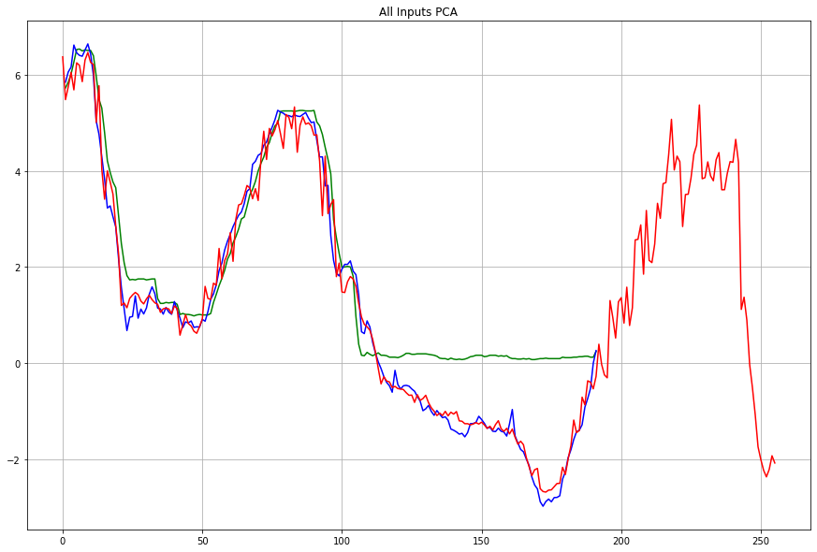

**Principal Component Analysis Coefficients**

**Neural Network Model using 2 PCA Scores**

**PCA Scores**

